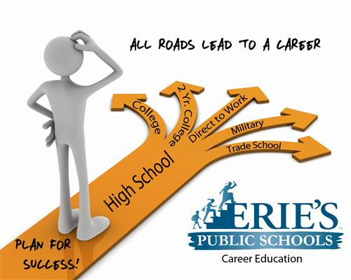

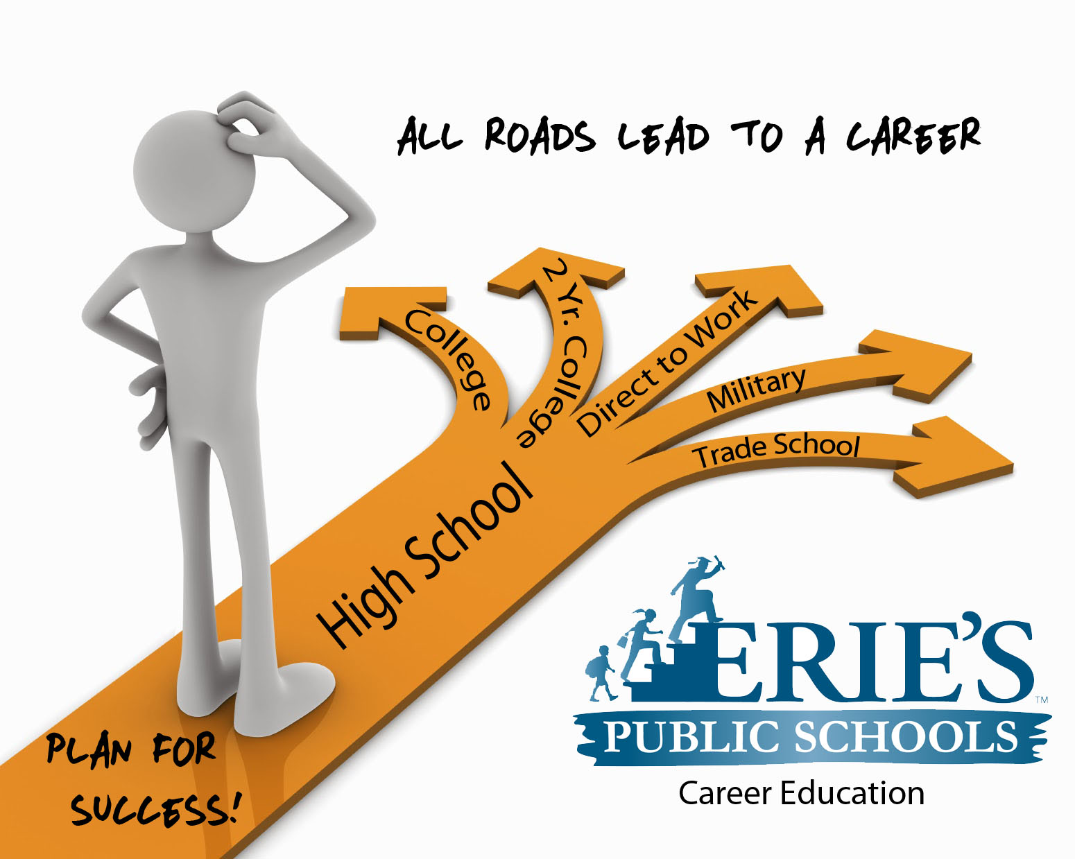

Pre-K-12 Career Guidance Comprehensive Plans

Erie’s Public School

Career Exploration CEW Standards

**Career Readiness Guide**

Special Thank You to the Career Readiness Committee:

* Mathew Pundt
* Tim Sabol
* Tammy Smith
* Nora Dolak
* Teresa Szumigala
* Mimi Fiorelli

**Mission Statement:** To implement, refine, and sustain a cohesive, meaningful career

development process for all students in grades K-12; one that is integrated within a rigorous

academic program, makes clear the connection between learning and life, and prepares

students for the challenge of their future, post-high school endeavors.

**Website: http://www.eriesd.org/domain/1703**

* Career Awareness implemented through the social studies curriculum in all grade levels for a minimum of 2 hours per quarter for a total of 8 hours of career awareness per year.
* Schools will Implementation of the PA Career Standards in all grade levels.
* Grades K-5 will utilize the web base site of cc:Sparks
* Grades 6-8 will utilize the web base site of cc:Springboard
* Grades 9-12 will utilize the web base site of WIN Learning with a career portfolio developed by graduation.
* Career Field Trips – virtual and site based in grades 4, 7 and high school.
* Graduation Portfolio
* All seniors to graduate with a career portfolio that includes resume, transcripts, letters of reference, writing samples, accomplishments and certificates.
* Electronic portfolio would follow the student from sixth through 12th grade.
* A hard and electronic copy of the portfolio would be made available upon graduation.

Public School (EPS) Students will be exposed to career awareness starting in pre-school that will continue through 12th grade. Career exploration programs such as Career Cruising and Win Learning will be part of the program to allow students to participate in the career exploration through web based software that explores careers and planning. The Career Exploration Program will be, supported by a Career Exploration Specialist that will work with school-based counselors and teachers to increase career exploration and portfolio development for all students in Erie’s Public Schools. Each grade level will integrate career exploration for every student for a minimum of 2 hours per quarter/total of 8 hours per year for all 13 grade levels.

**Grades Pre-K through 5**

**Pre-School through Grade 2**

* Students complete 2 hours of grade level reading and game activities that begin the process of exploring different careers using Career Cruising software.

**Grades 3 through 5**

* Students receive 2 hours of age appropriate activities in career education with the PA Common Core/workforce standards using Career Cruising software.
* Field trip for 4th grades in career fields

**Grades 6 through 12th**

* Career Interest surveys conducted to delineate students’ career interests at multiple grade levels and raise awareness of the academics required to pursue the fields of interest.
* 1 hour of Assessment using Career Cruising’s Career Matchmaker (6th – 8th Grade)
* 1 hour of Assessment using WIN Learning’s Interest Profiler (9th – 12th Grade)
* Virtual Career explorations will familiarize students with descriptions and expectations for different careers and career clusters through viewing videos relating to a variety of possible careers.
* 1 hour of Career Exploration Comparison Activity using career matches from corresponding assessments listed above.
* Field Trip for all 7th graders and high school for career related experiences.

Field trips to local businesses in the 4th, 7th and 10th grade years will provide students with opportunities to understand employer expectations and expand their knowledge of careers that are available in the region.

* Electronic Portfolios generated throughout the academic process so that graduating students receive a career portfolio including cover letters, a resume, certificates, samples of student work and other important documents that will be printed and organized into a hardcopy portfolio.
* Career Exploration Specialist will coordinate these efforts with school counselors in Grades K-12 to ensure that each component is fully integrated into existing curricula and will lead to college/career placement after graduation.

**Special Populations and Support Services**

Erie’s Public Schools has identified women, minorities and students living in poverty as high need groups that are especially vulnerable and underrepresented in STEM-based, information and health careers. The innovative content delivery methods described above as a core element of Career Exploration Plan have been designed, in part, to address these issues.

The Career Exploration Director will also collaborate with outside agencies to leverage existing supportive programs that provide wrap-around services to high-need students. Each of these programs represents a small-group learning environment built on strong relationship-building and extensive one-on-one time.

These programs include:

1. **Talent Search Program-** Administered by the Northwest Tri-County Intermediate Unit 5 (MOU attached), Talent Search is unique due to its early intervention building block. EPS middle school students participate in this program beginning in Grade 6 with college/career awareness activities. These activities will continue in Grades 9-12 with preparatory activities that intensify during the high school years including study skill courses, test taking techniques, time management techniques, tutoring and college access support.

2. **GoCollege**- A program administered by Gannon University, GoCollege provides academic assistance and career advising to students in Grades 9-12. The GoCollege High School orientation will be a key element of the mandatory orientation for students entering 9th grade.

3. **Upward Bound-** The Upward Bound program is administered by the Greater Erie Community Action Committee (GECAC) to assist low-income, first-generation students in Grades 9-12 prepare for careers in math and science. The program consists of an academic year component with bi-monthly workshops, tutoring, SAT/ACT prep, college access activities and Saturday day-trips to science/math-related venues.

**Career Guidance and the Career Exploration Specialist**

Erie’s Public Schools offer comprehensive Career Guidance services to assist students in making informed educational and occupational choices. The Career Exploration Specialist will work directly with school counselors and social studies teachers in each building to implement the Career Exploration Program for all students. Career Guidance will take on a more intense approach to prepare students for the changing 21st Century workplace. Core elements will include outreach, assessment, counseling, curriculum, program/job placement, follow-up, consultation and referral. A key component of Career Guidance will include dedicated time for school counselors to assist Erie’s Public Schools students in:

* navigating the planned sequence of activities/experiences required to achieve specific competencies (self-appraisal, decision making, goal setting and career planning)
* student accountability
* eliminating tendencies for gender bias and stereotyping with regard to career opportunities

All students in Erie’s Public School will have an Individual Career Development Plan (ICDP) that will be based on students’ strategic use of career exploration software beginning in 6th grade. This ICDP will be developed during the middle school years but will be modified/expanded as the student moves through career exploration sequences. Prior to each semester, the student will meet with his/her dedicated career counselor to evaluate the ICDP, use it to select courses for that semester and make any necessary changes to keep the student on track.

Erie’s Public Schools Career Guidance Services haves been designed to assist individuals in making and implementing informed educational and occupational choices. Our career guidance service develops an individual's competencies in career related field, in self-knowledge, educational and occupational exploration, and career planning.

Career Guidance Services help individuals acquire the knowledge, skills, and experience necessary to identify options, explore alternatives and succeed in society. These programs will prepare individuals for the changing workplace of the 21st century by:

* teaching labor market changes and complexity of the workplace
* broadening knowledge, skills, and abilities
* improving decision making skills
* increasing self-esteem and motivation
* building interpersonal effectiveness
* maximizing career opportunities
* improving employment marketability and opportunities
* promoting effective job placement
* strengthening employer relations

**Key Components of Successful Career Guidance Services:**

* A planned sequence of activities and experiences to achieve specific competencies such as self-appraisal, decision making, goal setting, and career planning
* Accountability (outcome oriented) and program improvement (based on results of process/outcome evaluations)
* Effective management to support comprehensive career guidance services
* A team approach where certified school counselors are central to the program
* Strong professional development activities so that school counselors can regularly update their professional knowledge and skills
* Varied approaches to program delivery such as outreach, assessment, counseling, curriculum, program and job placement, follow-up, consultation, referral
* Career development and activities specifically designed to meet the needs of special populations and eliminate gender bias and stereotyping

Under the direction of the Career Exploration Specialist, school counselors will be responsible for delivery of the Career Exploration Program, which will create opportunities to involve students in integrated academic and career education. Ultimately, and with the guidance of their school counselor, individual students will be encouraged to take on greater participation in their own future through the articulation of goals in either higher education or direct to the workforce placement. In turn, this approach will ensure program success on both the individual student level and on a regional scale with the development of young adults who prepare to, bolster the future of business and economic development in Erie County.

**Program Growth**

* Summer Career Camps in manufacturing and STEM will be planned for grade 6-9. The camps will provide an intensive look into careers with field trips and hands-on projects at Central Career and Technical school.

**Erie’s Public Schools - Career Education webpage**

* Go to Eriesd.org
* •Select Academics, drop down menu
* Select Career Education
* Explore

**Career Street – Local connection to Erie Businesses**

* Careerstreeterie.org
* Or access through the ESD Career Education: Career Opportunities

**Career Cruising**

ccSparks http://ccspark.careercruising.com/

ccSpringboard http://public.careercruising.com/us/en

**WIN Learning**

Career Readiness System http://www.wincrsystem.com/

Erie’s Public Schools Career Guidance Services has been designed to assist individuals in making and implementing informed educational and occupational choices. Our career guidance service develops an individual's competencies in career related field, in self-knowledge, educational and occupational exploration, and career planning.

Career guidance services in career and technical education help individuals acquire the knowledge, skills, and experience necessary to identify options, explore alternatives and succeed in society. These programs had better prepare individuals for the changing workplace of the 21st century by:

* teaching labor market changes and complexity of the workplace
* broadening knowledge, skills, and abilities
* improving decision making skills
* increasing self-esteem and motivation
* building interpersonal effectiveness
* maximizing career opportunities
* improving employment marketability and opportunities
* promoting effective job placement
* strengthening employer relations

**Students benefit from Career Guidance Services**

Everyone benefits-- male and female students, disabled, disadvantaged, minorities, limited English proficient, single parents, teachers, administrators, parents and employers.

**Key Components of Successful Career Guidance:**

* A planned sequence of activities and experiences to achieve specific competencies such as self-appraisal, decision making, goal setting, and career planning
* Accountability (outcome oriented) and program improvement (based on results of process/outcome evaluations)
* Effective management needed to support comprehensive career guidance services
* A team approach where certified counselors are central to the program
* Strong professional development activities so counselors can regularly update their professional knowledge and skills
* Different approaches to deliver the program such as outreach, assessment, counseling, curriculum, program and job placement, follow-up, consultation, referral
* Requires career development and activities for special populations
* Encourages elimination of sex bias and stereotyping

Counselors have opportunities to involve students in education and training that integrates academic and career education. Encourage individual students’ greater participation in further education by articulating post-secondary education and direct to the workforce placement, to provide services to all students: like at-risk or disadvantaged, to promote program outcomes and performance measures, and to respond to business and economic development of the Erie Community.

**Erie’s Public Schools Career Awareness Web Page**

**Go to the eriesd.org and select Academics. Under the drop down menu**

**select Career Education.**

* This main page will give you a description of the website and career links on the left hand side.
* Explore Career Opportunities for alternative websites with detail career options.
* Select elementary, middle or high school depending on the grade level you are teaching.
* Each level will break out by grade and have the PA Career Education and work strands.
* Select the grade level for the career objectives and the web link for the web-based program.
* Students sign in using their username and password.



Welcome to Career Education for Erie's Public Schools. These pages are designed for career exploration for all grade levels to support students through identifying their strengths, interests, and values. This valuable information will help prepare students today for a future career that has meaning and purpose.

Lessons and resources have been provided here for teachers to help students explore different careers and what it takes them to prepare for the career(s) that interest them. Identifying students strengths, interests, and values while exploring various career pathways and connecting them to the academics they take in school, is essential to preparing for a future as a skilled member of the work force.

Exploring is the first stage in charting their future and opportunities that interest them. Experiencing is the second way, by talking with adults who work in specific fields of interest and making plans to visit a work site to see the career in action. The third step is making an educational plan and determining what it takes to prepare for that career.

**Career Cruising Implementation Plan**

This document contains a variety of suggested activities to be completed each year

during the fall (September – December), the winter (January – March) and the spring

(April – June). Where applicable, the related Career Cruising Classroom Activity or

Portfolio Classroom Activity has been listed. These paper-based activities can serve as a

guide to you and your students as you work through the related sections of the program.

These activities can be found in the Helpful Information section of the program.

Additional activities, including group activities, are listed at the end of this document

should you wish to expand your use of the program beyond the suggested activities for

each grade.

The Career Advisor Management System (CAMS) allows you to track your students’

progress and to view your students’ work. For a more rigorous implementation, you can

choose to set the recommended activities below as requirements using the Portfolio

Completion Standards option. A sample Portfolio Completion Standards outline is

included in this document.

**Elementary (Pre-K-5)** Career Cruising:    [ccSpark](http://ccspark.careercruising.com/" \t "_blank)

Imagine a young girl who dreams of becoming an astronaut.  If she learns that she'll need a degree in Science, Engineering or Math to make her dream come true, then she's on her way.  With the right information delivered at the right time, in a way that's engaging and inspirational, she has a real chance to fulfill her potential.  ccSpark for K-5, uses a fun, educational role playing game called Sparkdale to help younger students learn about careers, life-planning and social skills.  It's unique, age-appropriate and inspiring.

ccSpark includes a series of games that cover more than seventy careers, from doctor to urban planner, landscaper to industrial designer, food scientist to web developer.  In each game the student takes the reins as the problem-solver, selecting where to go, who to talk to and what questions to ask.

At the end of each game, students complete activities designed to encourage reflection and apply early career development building blocks including personal reflection, real world planning, goal setting, and strategies for school success.

 Pennsylvania Career Education and Work Strands:

* 13.1 - Career Awareness and Preparation
* 13.2 - Career Acquisition
* 13.3 - Career Retention and Advancement
* 13.4 - Entrepreneurship

**Career Cruising K-2**

Students will complete Career Cruising using ccSpark! ccSpark! is a career education website that helps students plan their future by introducing and exploring different career opportunities. Students will meet six different people while trying to solve the mystery as a detective. Students will keep a profile and log of their expedition on their Dpad.

**Career Objectives**

* Students identify different kinds of work.
* Students identify current personal interests.
* Students will define a good worker.
* Students role-play different community jobs.
* Students match picture of worker to occupation.
* Students match tool to the worker.
* Students take field trips to learn about different jobs.
* Students will be introduced to different jobs through guest speakers/parents.

Grade 3

* " All About Me."  Explores personal interests, favorite school subjects, contribution at home, self-awareness, listening skills, taking initiative and the concept of career paths.

* Students will  complete 1-7 units of Career Cruising using ccSpark grade 3.   ccSpark! is a career education website that helps students plan their future by introducing and exploring different career opportunities.  Students will meet different people in Sparkdale while trying to solve the mystery as a detective. Students will keep a profile and be introduced to 6 different pathways.

[Career Education and Work Core\* Crosswalk-Grade 3](http://www.pacareerstandards.com/documents/crosswalks/3rd-grade-core-cew-and-all-academic-standards.pdf)  \

* <http://www.pacareerstandards.com/documents/crosswalks/3rd-grade-core-cew-and-all-academic-standards.pdf>

**Career Objectives**

* Students recognize that the roles of individuals are constantly changing.
* Students identify the range of jobs available in the community.
* Students learn about occupations in the various career concentrations.
* Students will identify attitudes and work habits that contribute to success at home and school.
* Students are instructed in diversity and gender equality in the workplace.
* Students set goals and design a plan of how to achieve them.
* Students compare nontraditional and traditional occupations.
* Students will define entrepreneurship.
* Students discuss entrepreneur character traits and opportunities.

**Grade 4**

* "My Success Tools."  Explores Learning Styles and study habits , occupation environments and tools, organization, bullying, cyber safety and coping skills.

* Students will  complete units 8-14 of Career Cruising using ccSpark grade 4.   ccSpark! is a career education website that helps students plan their future by introducing and exploring different career opportunities.  Students will meet different people in Sparkdale while trying to solve problems and keeping the town happy.   Students will keep a profile and be introduced to 6 different pathways.

[ccSpark!](http://ccspark.careercruising.com/) 

 Career Objectives:

* Students take field trips to learn about different jobs.
* Students  will be introduced to virtual visits and speakers.
* Students will be introduced to different jobs through career speakers or a speaker series.

**Grade 5**

* "Confidence Building."  Explores character traits, decision making, goal setting, adapting to change, negotiation skills, soft skills and self-esteem.

* Students will  complete units 15-21 of Career Cruising using ccSpark grade 5. Students will meet different people in Sparkdale while trying to problem solve and keeping the town happy.   Students will keep a profile and interest inventory.  These pathways include:  Business, Creative, Nature, Fixing and building, helping and health.

[ccSpark!](http://ccspark.careercruising.com/)

<http://www.pacareerstandards.com/documents/crosswalks/5th-grade-core-cew-and-all-academic-standards.pdf>

 Career Objectives:

* Students will interact with different tasks related to job areas.
* Students take field trips to learn about different jobs.
* Students will be introduced to different jobs through guest speakers/parents.

**6th Grade**

**FALL**

Each student should login to his or her personal Portfolio and review the “Things to Remember section.

* Complete the first 39 questions of Career Matchmaker
* Save Matchmaker Results as 6th Grade Results
* Activity #3 – Using Career Matchmaker
* Complete the Learning Styles Inventory and save results to the Portfolio.

**WINTER**

* Begin to explore career information by researching careers of interest using the keyword search. Students can then save one career they would like to explorefurther.

**SPRING**

* Make note of Hobbies and Interests in the Portfolio.
* How they relate to potential careers.

**7th Grade – Field Trip Year**

**FALL**

* Enter short and long term goals in the Career and Life Goals section of the Portfolio.
* Review their Matchmaker Results from 6th grade and any careers they saved to their portfolio. Have students update their career(s) of interest they’ve saved to their portfolio

**WINTER**

* Research careers by school subjecti\* and update their career(s) of interest to the Portfolio
* Activity #1 – School Subjects and Careers
* Students can then explore different industries of interest and can work either alone, or as part of a group to present their findings to their classmates including a description of at least two significant careers in the industry.

**SPRING**

* Update Hobbies and Interests in the Portfolio.
* Begin a journal by keeping track and reflecting on career development activities.

**8th Grade**

**FALL**

* Complete the first 39 questions of Career Matchmaker. Student should also specify the level of Education they’re planning. Save Matchmaker Results as 8th Grade Results and updating the Best Match.
* Activity #3 – Using Career Matchmaker
* Students can begin to review the College Planning Timeline

**WINTER**

* Research careers by cluster and save at least two careers of interest to the Portfolio.
* Students should also indicate in the Career Preparation section their top two clusters.
* Activity #7 – Career Clusters Research Project
* Answer additional Career Matchmaker questions. Students should have completed all 116 questions at this point.
* Activity #4 – Your Career Ideas and Career Matchmaker
* Students can include a brief reflection on their career suggestions by writing in My Journal

**SPRING**

* Begin planning their four-year plan (Education Plan)
* Make note of any new Hobbies and Interests.
* Include Extra Curricular Activities in the Portfolio.
* Review and update Career and Life Goals.

**9th Grade**

**FALL**

* Research careers using the Career Selector and save their results to the Portfolio.
* Students should also save another two careers of interest to the Portfolio.
* Activity #5 – Using Career Selector
* Review careers of interest and compare two possible career choices.
* Activity #6 – Comparing Careers
* Review the College Planning Timeline
* Have students delete their previous Learning Styles Inventory results and retake the assessment. Explain that their learning styles may have changed since they last took this inventory in the 6th grade.
* Review High School Courses needed for the career.

***WINTER***

* Using the information they have gathered about different careers, students can prep area pamphlet, presentation, report, etc., about one of their careers of interest. Students can draw upon the information they recorded in Activity #6 – Comparing Careers as starting point. Students can then reflect on their work using My Journal.

**SPRING**

* Update Four-year plan (Education Plan) – high school courses.
* Update Hobbies and Interests and Extracurricular Activities and have students select five Skills and Abilities to include in their Portfolio. Students can describe how they can demonstrate each skill using the comments section.
* Activity #10 – Discovering your Work Skills
* Review and update Career and Life Goals.

**10th Grade – Field trip year – concentrated in area of study**

**FALL**

* Complete Career Matchmaker. Student should specify the level of education they’re planning and saving results as 10th grade results and updating the Best Match. Save any new careers of interest to the Portfolio. Students can reflect on their new career suggestions and discuss the comparison of the two lists using My Journal.
* Review the Post-Secondary Planning Timeline or direct to the workforce goals.

**WINTER**

* Review the educational requirements for at least two careers of interest. Explore Career Cruising’s Explore Schools section and save two schools of interest that they have explored. Students can note their comments in the Your Thoughts section.
* Activity #12 – College Research Exercise
* Activity #13 – Finding the Right College

**SPRING**

* Update Four-year plan (Education Plan)
* Using the Resume Builder, complete a first draft resume, including any relevant hobbies, extracurricular activities, work experiences or volunteer experiences.
* Portfolio Activity #9 – Using the Resume Build**er**
* Review and update Career and Life Goals.

**Grade 11**

**FALL**

* **Complete My Skills Assessment for the Career Matchmaker results reflecting the best match results, and save results to Portfolio. Students can then describe a plan for developing the necessary skills for careers of interest using My Journal.**
* **Activity #11 – Using My Skills**
* **Review the College Planning Timeline**

**WINTER**

* **Using the list of Careers that Interest Me, students should choose a career and, from the career profile page, click on the Search for Jobs button to see if there are any job opportunities in that field in your community or if they would need to move to find work in that field. Students can reflect on their search using My Journal.**
* **Complete the School Selector and save an additional two schools of interest.**

**SPRING**

* **Update Four-year plan (Education Plan)**
* **Complete the Ability Profiler assessment.**
* **Review list of saved schools, and compare two schools research two programs of interest to see which schools offer those programs. Using the Your Thoughts section, make note of admission requirements, costs, campus services, athletics etc.**
* **Complete the Post-Secondary Plan component of the Portfolio.**
* **Update Resume.**
* **Review and update Career and Life Goals.**

**Grade 12**

**FALL**

* **Review Four-year plan (Education Plan)**
* **Review the College Planning Timeline**
* **Review list of saved schools**
* **Begin to explore scholarships and make note of application deadlines**
* **Update Resume and export to Microsoft Word to further polish their work. Save the updated resume to the My Files section of the Portfolio.**
* **Review Employment Guide section on letter writing and prepare a cover letter for the resume. Add the cover letter to the My Files section of the Portfoliov.**

**WINTER**

* **Review the interview skills section of the Employment Guide and have students participate in mock interviews. Students can complete the Interview Evaluation worksheet and include in the My Files section of the Portfolio.**

**SPRING**

* **Review the Post-Secondary plan and make any necessary changes.**
* **Review and update Career and Life Goals.**
* **Students can submit a final hard-copy draft of their resume and cover letter, along with the interview evaluation as a final project. Added to their career portfolio, graded and given to the student for college or job seeking.**
* **Students can reflect on their career preparation experiences throughout high school in the My Journal section.**

**GRADUATION**